INTERNAL ASSIGNMENT – 02
Comparative Study and Implementation of Generative AI Models
Submitted by-
Sanskar Ramesh Meharkar: 202401110029
Meghana Shirish Innani : 202401110009
Dewesh Barapatre: 202401110053
Google Colab link: https://colab.research.google.com/drive/1fm5EdQ33McorXnu9g1bgzVHw_6xQ9uq4?usp=sharing

Github Link:-
https://github.com/Sanskarmeharkar/Assignment-No.-2-AI-Assisted-Comparative-Study-and-Implementation-of-Generative-AI-Models

1. Introduction and Objectives
Generative models learn what data looks like, rather than just labelling it, so that they can rebuild an input or create new examples that look like they came from the same source. In this assignment we compared four of them on face images: an Autoencoder (AE), a Variational Autoencoder (VAE), a Deep Convolutional GAN (DCGAN) and a pretrained Diffusion Model. Our aim was to see in practice how they differ in output quality, training behaviour and computing time.
Objectives:
(1) understand how each model is built and trained;
(2) run all four in a Colab notebook and record their real outputs, losses and times;
(3) compare their strengths, weaknesses and uses.

2. Dataset and Experimental Setup
We used the Labeled Faces in the Wild (LFW) dataset (13,233 images found in the downloaded archive). The notebook shuffles the image paths and keeps 4,000 images. Each image is converted to RGB, resized to 64 × 64 and scaled to the range [0, 1], giving an array of shape (4000, 64, 64, 3). This is split 90/10 into 3,600 training and 400 validation images (random seed 2024). AE, VAE and DCGAN were trained from scratch with TensorFlow/Keras. The diffusion model was not trained: we used the pretrained segmind/tiny-sd model (PyTorch, Hugging Face Diffusers) on a Colab GPU for inference only. For the DCGAN the images were rescaled to [−1, 1] to match its tanh output.
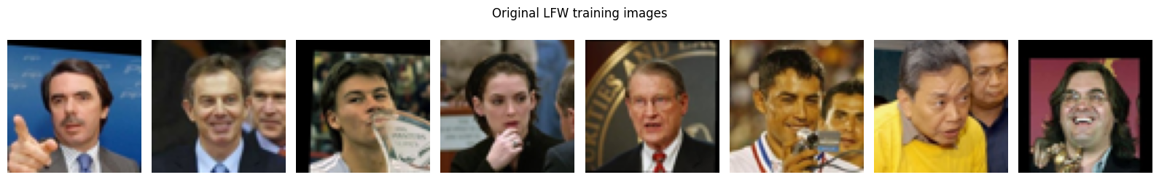
Figure 1: Sample LFW training images (notebook output)
Table 1: Experimental settings
Model | Approach | Key settings
AE | Trained, 15 epochs | 256-d latent; MSE loss; Adam (lr 1e-3); batch 64
VAE | Trained, 15 epochs | 256-d latent; BCE (summed over pixels) + KL loss; Adam (lr 1e-3); batch 64
DCGAN | Trained, 40 epochs | 100-d noise; BCE adversarial loss; label smoothing (0.9), input noise (0.05), BatchNorm, Dropout 0.3; Adam (G lr 2e-4, D lr 1e-4, β1 0.5); batch 64
Diffusion | Pretrained, inference | segmind/tiny-sd; 20 steps; guidance scale 7.0

3. Practical Implementation and Results (Task 2)

3.1 Autoencoder (AE)
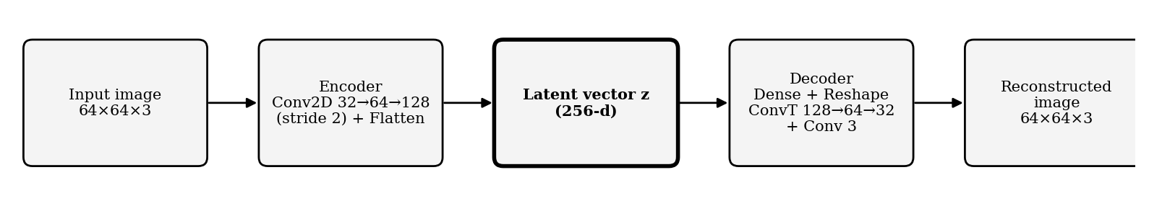
Figure 2: Autoencoder architecture
The encoder uses three strided convolution layers (32 → 64 → 128 filters, spatial size 64 → 32 → 16 → 8) and a dense layer that squeezes each image into a 256-number latent vector. The decoder rebuilds the image with a dense layer, three transposed convolutions and a final sigmoid convolution (4,536,707 trainable parameters in total). Training minimises the Mean Squared Error, MSE = (1/N) Σ (xᵢ − x̂ᵢ)².
Over 15 epochs (37.3 s), validation loss fell from 0.0482 to 0.0103 and training loss from 0.0705 to 0.0080. The two curves stayed close for most of training, but from about epoch 10 the training loss kept falling while the validation loss flattened and fluctuated (0.0120 at epoch 10, 0.0103 at epoch 15). The small gap at the end (0.0080 vs 0.0103) is a mild sign that the model fits the training images slightly better than unseen ones. On the 400 validation images the AE reached MSE 0.01030, PSNR 20.24 dB and SSIM 0.5988. The reconstructions (Figure 3) keep face position, skin tone, hair colour and background brightness, and some features such as glasses and a moustache remain faintly visible, but fine texture, eyes and edges are blurred. This blur is typical of MSE, which rewards a safe “average” image.
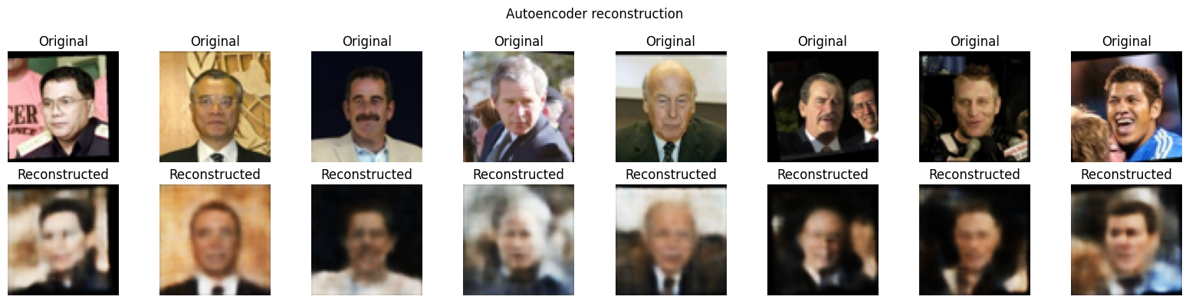
Figure 3: Input images (top) vs AE reconstructions (bottom) (notebook screenshot)
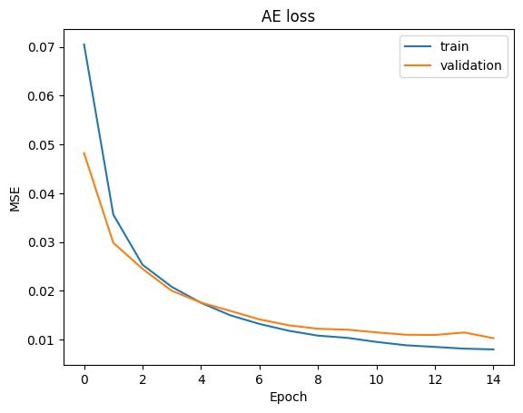
Figure 4: AE training and validation loss over 15 epochs (notebook output)

3.2 Variational Autoencoder (VAE)
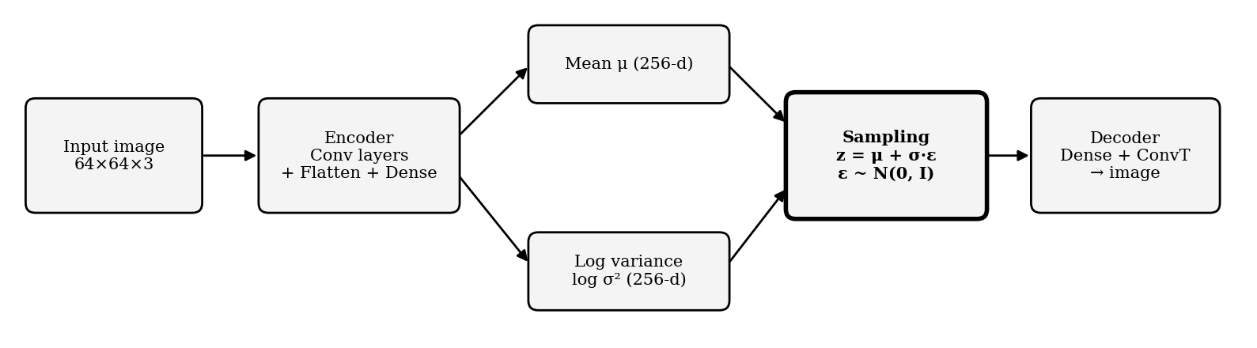
Figure 5: VAE architecture
Instead of a single point, the VAE encoder outputs a mean μ and log variance log σ² for each image. A latent vector is sampled as z = μ + σ · ε with ε ~ N(0, I) (the reparameterization trick), which keeps the network trainable by backpropagation. The loss is L = L_reconstruction + L_KL. The KL term pulls the latent space towards a standard normal distribution, so new faces can be sampled from it.
After 15 epochs (34.9 s), the training loss fell from 7,907.43 to 6,615.38 (reconstruction 6,497.85, KL 117.53). On the validation set the total loss was 6,662.85 (reconstruction 6,545.64, KL 117.22). The KL term rose from 21.44 to 117.53 during training, meaning the encoder used more of the latent space while still keeping it close to N(0, I). On the 400 validation images the VAE reached MSE 0.02337, PSNR 16.60 dB and SSIM 0.4194, below the AE on all three measures. Its reconstructions (Figure 6) are much smoother: broad pose, colour and lighting are kept, but individual detail is largely lost and many faces look like an averaged face.
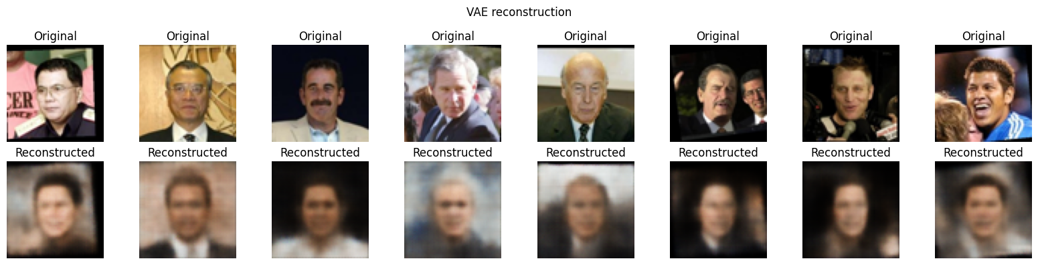
Figure 6: Input images (top) vs VAE reconstructions (bottom), same eight inputs as Figure 3 (notebook screenshot)
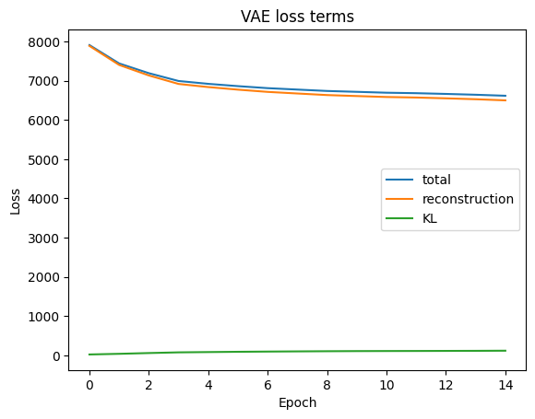
Figure 7: VAE loss terms over 15 epochs (notebook output)
Sampling latent vectors from N(0, I) and decoding them (Figure 8) produces blurry, brown-toned images with a head shape and sometimes a hint of eyes and hair, but no sharp features. This shows that the VAE latent space can be sampled, although the generated faces are low in detail.
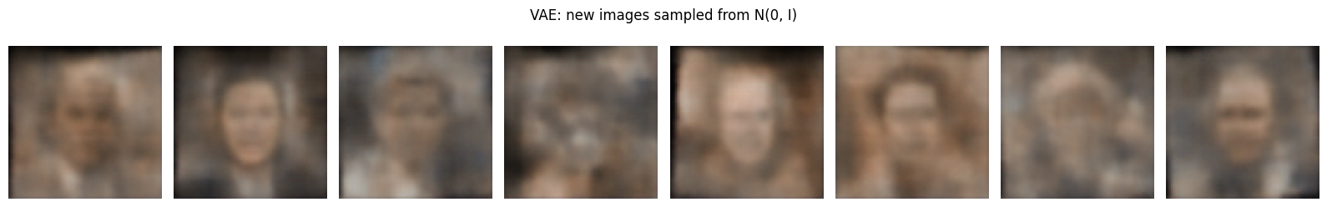
Figure 8: New images sampled from the VAE latent space (notebook output)

3.3 Deep Convolutional GAN (DCGAN)
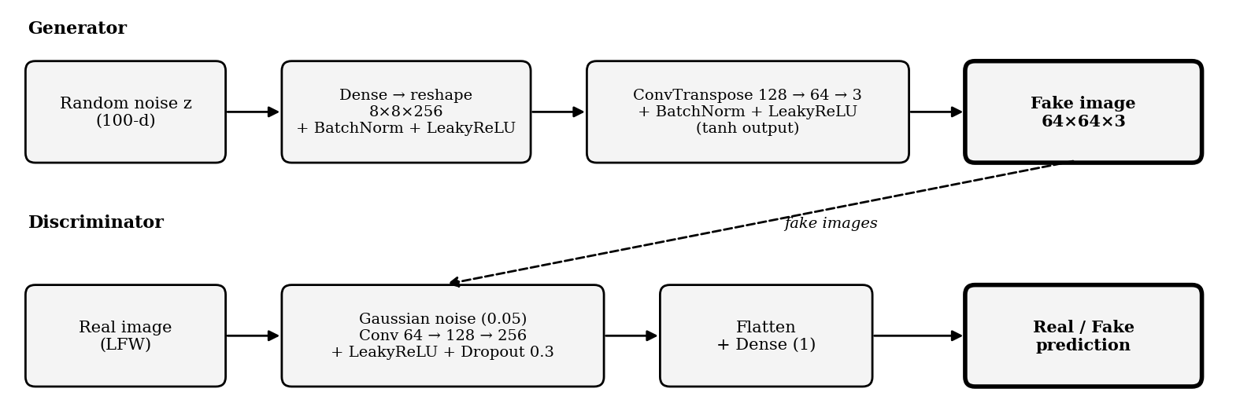
Figure 9: DCGAN generator and discriminator
A generator turns 100-d random noise into a 64 × 64 image, and a discriminator tries to tell real images from fake ones. The two are trained in turn on the objective min_G max_D E[log D(x)] + E[log(1 − D(G(z)))]. We used batch normalisation in the generator, dropout and input noise in the discriminator, one-sided label smoothing (real label 0.9) and a slower discriminator learning rate (1e-4 against 2e-4 for the generator).
After 40 epochs (138.8 s), the generator loss was 0.8875 and the discriminator loss 1.2795. Both losses changed quickly in the first epochs (generator loss peaked at 1.5209 in epoch 2 while the discriminator loss rose from 0.8655 to about 1.40 by epoch 6) and then stayed in a narrow band: the generator loss between about 0.81 and 0.87 up to epoch 30, and the discriminator loss between about 1.32 and 1.40. With label smoothing, a discriminator that outputs 0.5 for every image has a loss of 2·ln 2 ≈ 1.386, so these values are close to chance-level behaviour. In the last ten epochs the generator loss rose slightly (up to 0.9930) and the discriminator loss fell (down to 1.2548), so the discriminator became slightly better than chance late in training. GAN losses only describe how the two networks are doing against each other, and they flattened while the images were still improving.
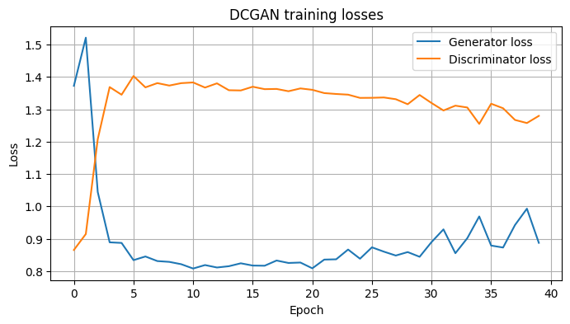
Figure 10: DCGAN losses over 40 epochs (notebook output)
Figure 11 shows the same fixed noise vectors at epochs 1, 10 and 40. At epoch 1 every sample is a nearly identical grey texture. By epoch 10 face-like layouts appear, but with strong colour casts and vertical stripe artefacts. At epoch 40 the samples show recognisable face structure (hair, forehead, eyes, collar) with different backgrounds and hair tones, so the output is varied rather than repeated, but the images are still blurry and carry a visible grid-like artefact pattern. They are clearly not photorealistic.
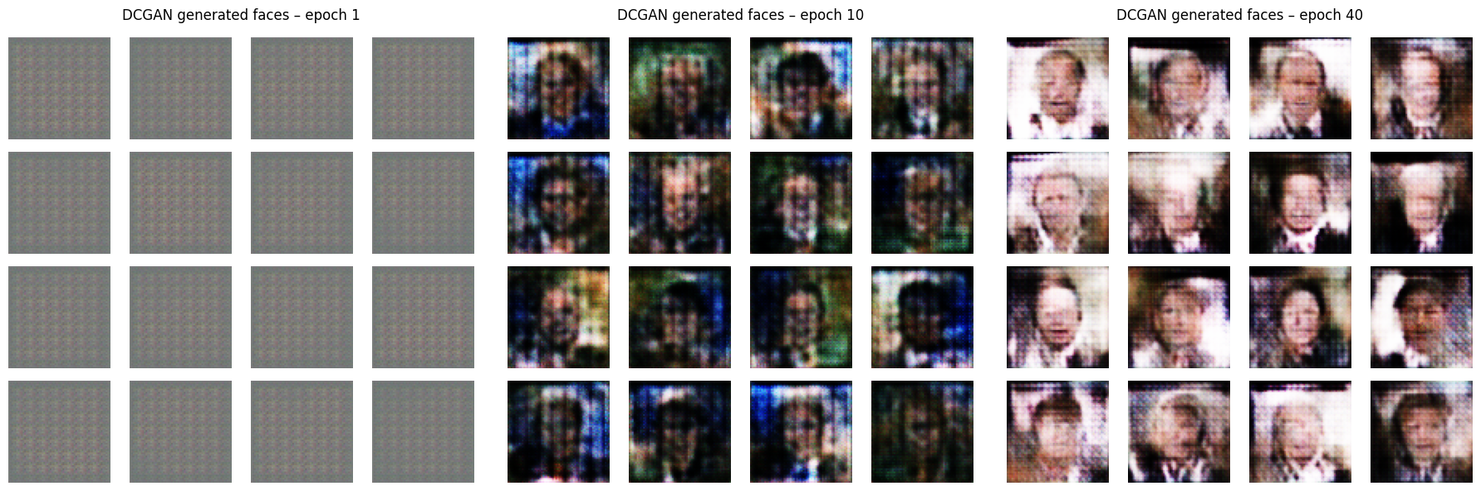
Figure 11: DCGAN samples from the same noise at epochs 1, 10 and 40 (notebook output)

3.4 Diffusion Model (pretrained)
A diffusion model learns to reverse a gradual noising process. Starting from random noise, a U-Net guided by the text prompt removes noise over many steps, and a VAE decoder turns the result into an image. Using segmind/tiny-sd with 20 steps and guidance scale 7.0, we generated three 512 × 512 portraits from three prompts: “A realistic close-up portrait photograph of a smiling middle-aged man, soft natural daylight, neutral background”, “A realistic portrait photograph of a young woman with short dark hair, studio lighting, high detail” and “A realistic portrait photograph of an elderly person with glasses, neutral background, high detail”. Each took about 2.03 s (2.03, 2.04 and 2.03 s).
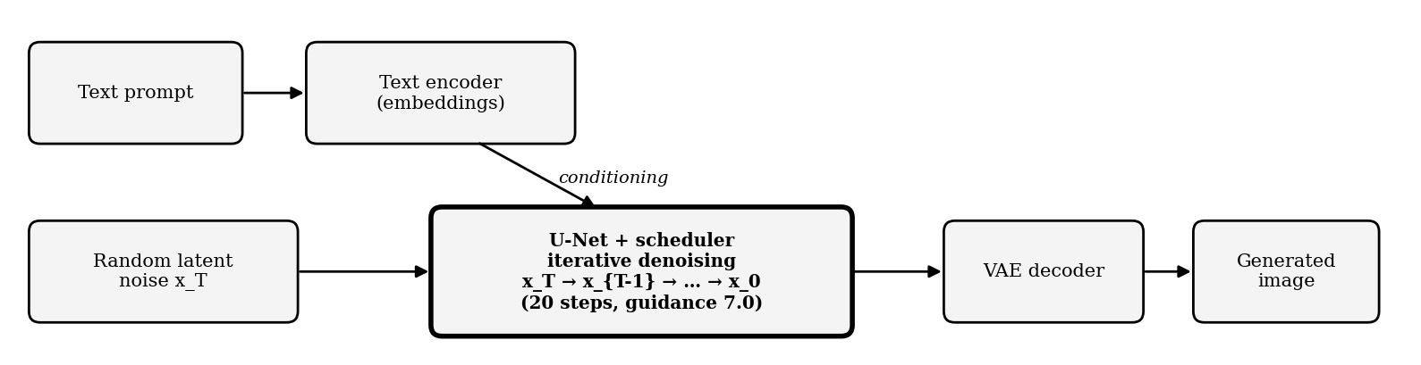
Figure 12: Text-to-image diffusion workflow
The elderly-person portrait is sharp and realistic. The middle-aged man is rendered in rich detail (skin lines, hair, stubble) but is tightly cropped and shows a small blue speck near the nose; the young woman’s portrait is smooth and slightly soft, also with a small blue speck on the forehead. So the model produces far more detailed and realistic faces than our trained models, but not flawlessly. The comparison is also not like-for-like: the model was pretrained on a huge dataset and never saw LFW.
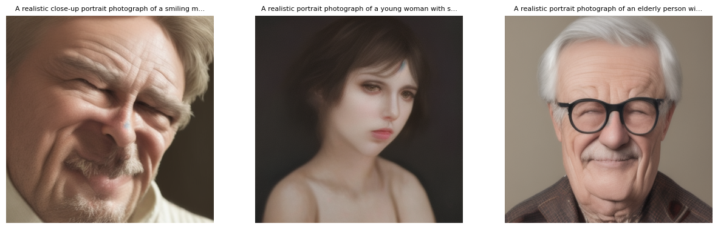
Figure 13: Portraits generated by segmind/tiny-sd (notebook output)

4. Comparative Study of the Four Models (Task 1)
Table 2 brings together the comparison required by Task 1: working principle, architecture and major components, advantages, limitations, applications, and how the outputs differed in our experiment.
Table 2: Comparison of AE, VAE, DCGAN and pretrained Diffusion Model
Criterion | Autoencoder (AE) | Variational AE (VAE) | DCGAN | Diffusion (pretrained)
Working principle | Compresses an image to a latent vector and rebuilds it; minimises MSE | Encodes image as a distribution (μ, σ); samples z = μ + σ·ε; loss = reconstruction + KL | Generator creates fakes from noise; discriminator separates real/fake; trained adversarially | Learns to remove noise step by step; starts from noise and denoises, guided by a text prompt
Architecture and major components | Conv encoder → 256-d latent → transposed-conv decoder | Conv encoder → μ and log σ² → sampling layer → decoder | Generator (dense + transposed conv) and discriminator (conv + dense) | Text encoder, U-Net, noise scheduler, VAE decoder
Advantages | Simple, fast, stable training | Smooth latent space; can sample new images | Creates new images that are sharper than VAE samples | Highest quality; prompt control
Limitations | Blurry; loses fine detail | Even smoother/softer outputs | Unstable training; artefacts; mode collapse | Heavy compute; may not follow prompt exactly
Applications | Compression, denoising, anomaly detection | Representation learning, data augmentation | Face synthesis, data augmentation | Text-to-image, design, concept art
Output in our experiment | Reconstruction close to input but blurred (MSE 0.01030, PSNR 20.24 dB, SSIM 0.5988) | Smoother, less detail (MSE 0.02337, PSNR 16.60 dB, SSIM 0.4194) | New 64×64 faces, varied but blurry with visible artefacts | Detailed, realistic 512×512 portraits (small artefacts)

Table 3: Measured results from the executed notebook
Model | Time (s) | MSE | PSNR (dB) | SSIM | Final loss
AE | 37.3 | 0.01030 | 20.24 | 0.5988 | val MSE 0.0103
VAE | 34.9 | 0.02337 | 16.60 | 0.4194 | val total 6,662.85
DCGAN | 138.8 | – | – | – | G 0.8875, D 1.2795
Diffusion | 2.03 (per image) | – | – | – | –

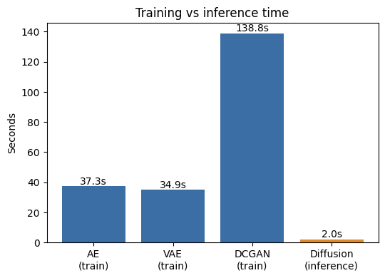
Figure 14: Execution time: training vs inference (notebook output)
The DCGAN took about 3.7 times as long as the AE (138.8 s against 37.3 s) and about 4 times as long as the VAE (34.9 s), because it updates two networks per step and ran for 40 epochs instead of 15. The diffusion time (2.03 s) covers generating one image with already-trained weights, so it should not be compared with the training times. The loss values cannot be compared across models either. The AE’s MSE is averaged per pixel, the VAE’s loss is summed over all pixels plus a KL term, and the GAN losses only describe how the two networks are doing against each other. So a VAE loss of 6,663 is not “worse” than an AE loss of 0.0103. The fair cross-model comparison is the images themselves, plus PSNR and SSIM for the two reconstruction models.

5. Output Analysis

5.1 Activity A – Image Reconstruction (CO3)
Input and method: the same eight input images, taken from the 400 held-out validation faces, were passed through both trained models (Figures 3 and 6) and the outputs were compared for blurring, distortion and loss of detail.
- AE kept face position, shape, skin tone and lighting, and faintly kept features such as glasses and a moustache, but hair texture, eye detail and background edges were blurred. Validation MSE fell from 0.0482 to 0.0103; PSNR 20.24 dB, SSIM 0.5988 (37.3 s).
- VAE outputs were smoother and less detailed than the AE’s; many faces look “averaged”. PSNR 16.60 dB (3.64 dB lower) and SSIM 0.4194 are both lower, and the validation MSE is about 2.3 times higher (0.02337 against 0.01030). The KL term organises the latent space, which allows sampling but costs sharpness (34.9 s).
- Overall: for faithful reconstruction AE > VAE on every measure we recorded; the VAE trades accuracy for a latent space we can sample from.

5.2 Activity B – Image Generation (CO4)
- VAE sampling (Figure 8): faces drawn from N(0, I) are blurry and brown-toned with weak facial structure, which shows that the VAE decoder produces smooth but low-detail images.
- DCGAN produced new face-like 64 × 64 images that do not exist in the dataset, with varied backgrounds and hair tones but with blur, colour noise and grid-like artefacts. Losses ended at G = 0.8875, D = 1.2795 (training 138.8 s). With only 3,600 training images and 40 epochs, this is expected.
- Diffusion produced far more realistic and detailed 512 × 512 portraits in about 2.03 s each (Figure 13), with only small artefacts. Its advantage comes from large-scale pretraining, so the comparison is not like-for-like.
- Quality, realism, detail and limitations: the DCGAN output is low resolution (64 × 64), blurry and carries grid-like artefacts, with no fine detail such as sharp eyes or skin texture. The diffusion output is high resolution (512 × 512) with realistic skin, hair and lighting, but it can still show small artefacts, and its output depends on the text prompt rather than on the LFW data. The DCGAN is cheap to sample but needs training; the diffusion model needs no training but is a large pretrained network.
- Overall: realism and detail: Diffusion > DCGAN > VAE; faithfulness to input: AE > VAE. Loss values were not compared across models because each uses a different loss function and scale.
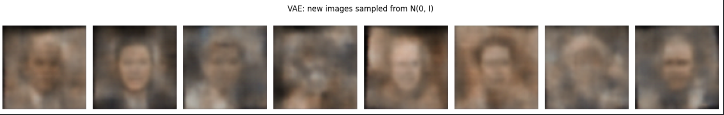
Fig 15.New images sampled from the VAE latent space (notebook output)
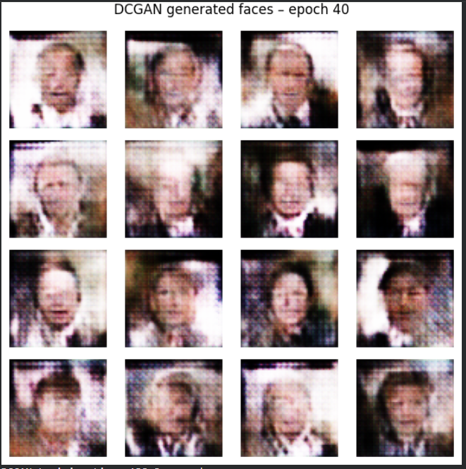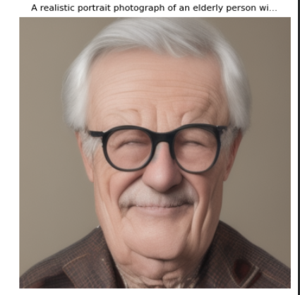

Figure 16: DCGAN (trained by us, 64×64) vs pretrained diffusion model (512×512)

5.3 Limitations
Only 4,000 images at 64 × 64; short training runs; the same 400 validation images were used both to monitor training and to report the final metrics (there was no separate test set); quality of the generated images was judged visually, with PSNR/SSIM for the reconstruction models only and no FID for the generators; the diffusion model was pretrained rather than trained by us; and each experiment was run once with a single random seed.

6. Group Reflection and AI Usage (Task 3)
AI tools used: Claude, for concept explanations, building and debugging the Colab notebook, and structuring and writing this report. All experiments were run by the group in Google Colab, and all results in this report come from that run.
Table 4: Important prompts used
Purpose | Prompt (summary)
Notebook | “Build a Colab notebook that trains an AE, VAE and DCGAN and runs a pretrained diffusion model, with timings and PSNR/SSIM, in the same style as the sample notebook but on the LFW face dataset.”
Code | “Explain this Colab notebook cell by cell and why the VAE uses the reparameterization trick.”
Report | “Make a report like the template using my notebook and screenshots; use only the actual results and do not invent values.”
Comparison | “Compare AE, VAE, DCGAN and Stable Diffusion on working principle, architecture, advantages, limitations and applications in one table.”

Verification process: every number in this report (losses, epochs, times, dataset sizes, PSNR/SSIM) was checked against the executed notebook output; model explanations were cross-checked with the original papers (Kingma & Welling 2014; Goodfellow et al. 2014; Radford et al. 2016; Ho et al. 2020) and the TensorFlow and Hugging Face Diffusers documentation; screenshots are taken directly from the notebook. AI-suggested statements that could not be verified were removed.
Key learning outcomes: how encoder–decoder models compress and rebuild images; why VAE outputs are smoother than AE outputs; how adversarial training works and why GAN losses do not show image quality; how diffusion models generate images from noise using a prompt; and why training time and inference time must be compared separately.
Table 5: Contribution of each member
Member | Contribution
Sanskar | Ran the AE and VAE experiments, captured reconstruction screenshots and wrote the Activity A analysis.
Meghana | Ran the DCGAN andpretrained diffusion experiments, captured generated outputs and loss graphs, and wrote the Activity B analysis.
Dewesh | Prepared the comparative table, documented AI tools, prompts and verification, and compiled the report.

7. Conclusion
Each model suits a different job. AE and VAE are good for reconstruction and learning compact representations (the AE more accurate, the VAE with a latent space we can sample from), DCGAN for generating new images from a specific dataset when there is enough data and training time, and diffusion models for high-quality, prompt-controlled generation if the computing cost is acceptable. With more data, higher resolution, longer training, a separate test set and proper metrics such as FID, the trained models could be compared much more rigorously, and fine-tuning a diffusion model on LFW would make the comparison fair.

References
[1] G. B. Huang, M. Ramesh, T. Berg and E. Learned-Miller, “Labeled Faces in the Wild,” Univ. of Massachusetts Amherst, Tech. Rep. 07-49, 2007. https://vis-www.cs.umass.edu/lfw/
[2] D. P. Kingma and M. Welling, “Auto-Encoding Variational Bayes,” ICLR, 2014.
[3] I. Goodfellow et al., “Generative Adversarial Nets,” NeurIPS, 2014.
[4] A. Radford, L. Metz and S. Chintala, “Unsupervised Representation Learning with Deep Convolutional GANs,” ICLR, 2016.
[5] J. Ho, A. Jain and P. Abbeel, “Denoising Diffusion Probabilistic Models,” NeurIPS, 2020.
[6] Segmind, “segmind/tiny-sd,” Hugging Face. https://huggingface.co/segmind/tiny-sd
[7] Project Colab notebook (Generative AI Assignment 02): https://colab.research.google.com/drive/1fm5EdQ33McorXnu9g1bgzVHw_6xQ9uq4?usp=sharing

